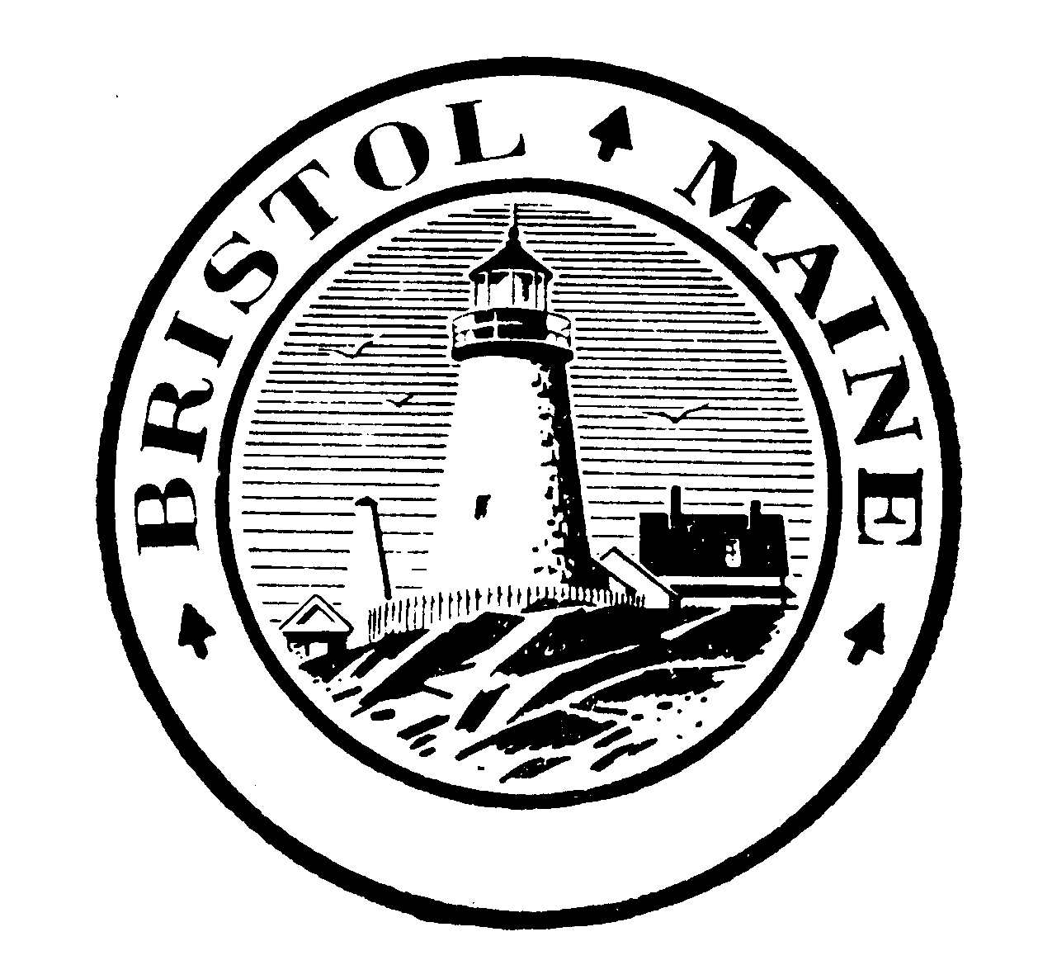
Bristol Selectmen’s Agenda
Bristol Town Office, January 5th, 2022: 7:00 pm

Public Hearing: Proposed amendments to the Flood Plain Management Ordinance of 2015, to incorporate changes in state law.
Regular Select Board Meeting:
- Minutes of Meeting of December 22nd, 2021
- Update on open positions
- Contract renewal for 2022, Shellfish Warden (Brent Barter)
- Policy on Remote Meetings (tabled December 22nd)
- Discussion of retirement plan options (tabled December 22nd)
- 2022 Budget review, continued
- Warrants for Payroll and Accounts Payable
- Correspondence
- Public Comments
- Notice of forthcoming meetings:
- Fish Committee, Thursday, January 6th, 4 pm at the Bristol Town Office
- Budget Committee, service provider hearings: Tuesday, January 11th, 7.00 pm by Zoom. To receive a Zoom access code, notify the Town Office by 4.00 pm on January 11th.
- Bristol / South Bristol Transfer Station Board: Wednesday, January 12th, 6.30 pm at the Bristol Town Office
- Comprehensive Plan Committee: Thursday, January 13th, 7.00 pm by Zoom. To receive a Zoom access code, notify the Town Office by 4.00 pm on January 13th.
- Parks and Recreation Commission, Tuesday, January 18th, 6.00 pm at the Ellingwood Information Center
- Select Board, Wednesday, January 19th, 2022, 6.30 pm at the Town Office
- Harbor Committee, Thursday, January 20th, 5 pm at the Bristol Town Office
- Adjournment

